Autumn 1
Week 1 | Week 2 | Week 3 | Week 4 | Week 5 | Week 6 | Week 7
 | 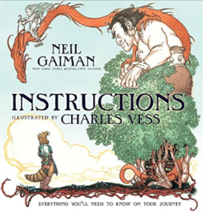 |  | 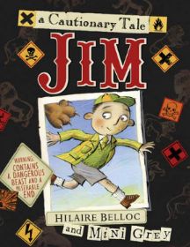  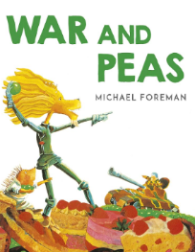  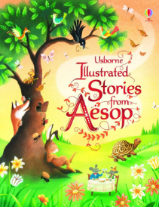  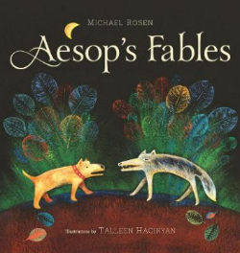
Sentence level | Instructions |  | Incidental writing opportunities: diary entry, thought bubbles, setting description, ‘live’ news report, persuasive speech  Main writing outcome: narrative (fable)
Autumn 2
Week 1 | Week 2 | Week 3 | Week 4 | Week 5 | Week 6 | Week 7
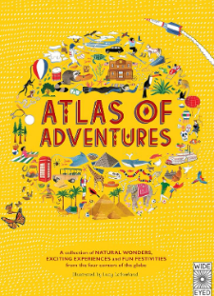 |  |  | 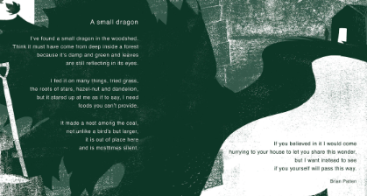  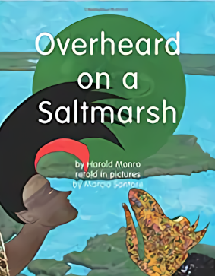  A small dragon - Brian Patten |  |  | 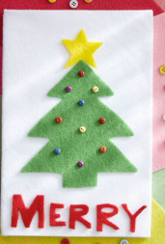
Incidental writing opportunities: postcard, radio broadcast, glossary, diary entry  Main writing outcome: information leaflet |  |  | Incidental writing opportunities: description, diary entry  Main writing outcome: free verse poem |  |  | Christmas cards

Spring 1
Week 1 | Week 2 | Week 3 | Week 4 |  | Week 5 | Week 6 | Week 7
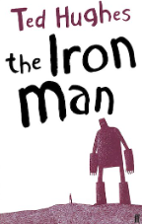 |  |  |  | 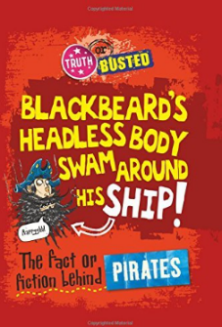  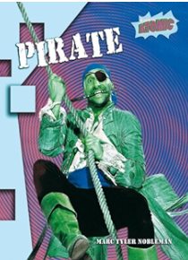  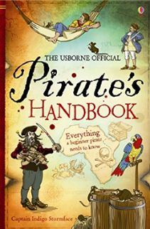  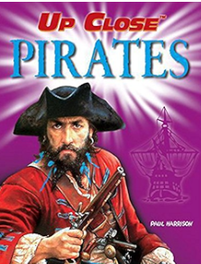
Incidental writing opportunities: 1st person recount, summary, character description, letter of complaint, diary entry  Main writing outcome: narrative ending |  |  |  | Incidental writing opportunities: character profile of a pirate, descriptive scene  Main writing outcome: non-chronological report
Spring 2
Week 1 | Week 2 | Week 3 | Week 4 |  | Week 5
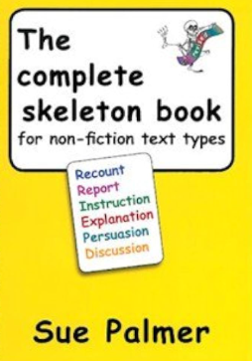  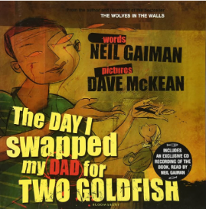  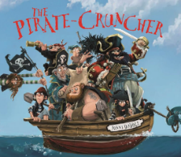  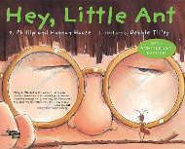 |  |  | 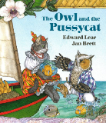  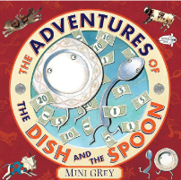  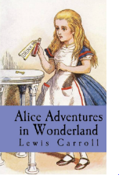  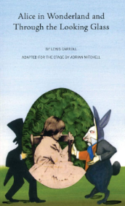  ABC poem – Spike Milligan
Incidental writing opportunities: poster, postcard, leaflet  Main writing outcome: persuasive writing |  |  |  | Incidental writing opportunities: review, summary, diary entry, mini playscript  Main writing outcome: playscript

Summer 1
Week 1 | Week 2 | Week 3 | Week 4 |  | Week 5 |  | Week 6
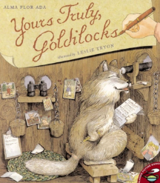  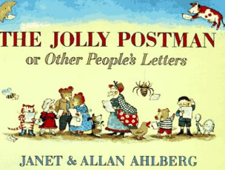  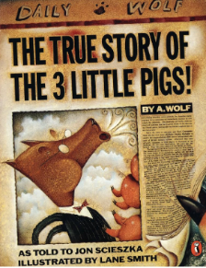 |  |  |  | 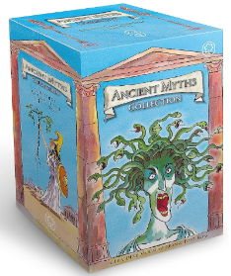  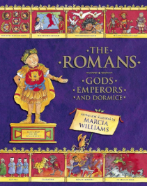
Incidental writing opportunities: summary, speech bubbles, live news report  Main writing outcome: newspaper report (recount) |  |  |  | Incidental writing opportunities: school report, poem, myth opening, note to a friend, diary entry, summary, news reports  Main writing outcome: extended, invented myth
Summer 2
Week 1 | Week 2 | Week 3 | Week 4 |  | Week 5 |  | Week 6 | Week 7
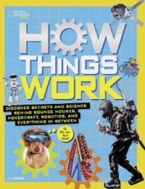  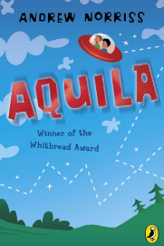  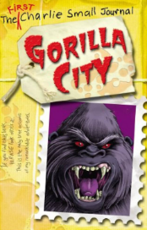  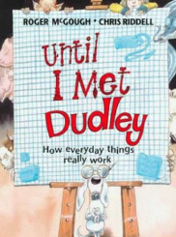 |  |  | Words are Ours, by Michael Rosen  The Magic Box, by Kit Wright |  |  |  | 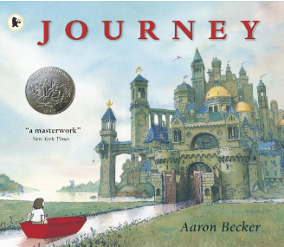
Main writing outcome: explanation of how something works |  |  | Incidental writing opportunities: poem review  Main writing outcome: free verse poem |  |  | Transition text writing opportunities: diary, setting description, character description, narrative, postcards

