Autumn 1
Week 1 | Week 2 | Week 3 | Week 4 | Week 5 | Week 6 | Week 7
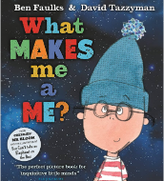 | 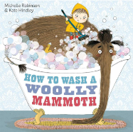 |  | 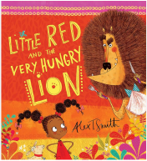 |  | 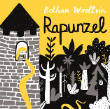  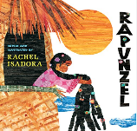
Sentence level | Main writing outcome: instructions |  | Incidental writing opportunities: character description  Main writing outcome: narrative retell |  | Incidental writing opportunities: character description  Main writing outcome: diary entry
Autumn 2
Week 1 | Week 2 | Week 3 | Week 4 | Week 5 | Week 6 | Week 7
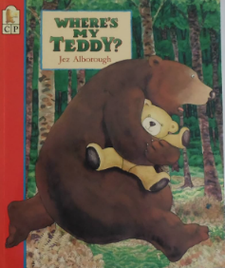  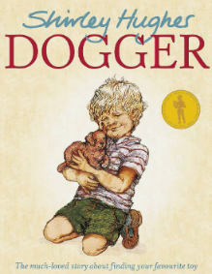  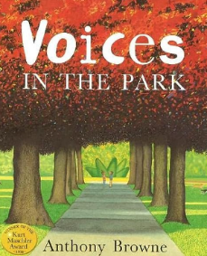 |  |  | 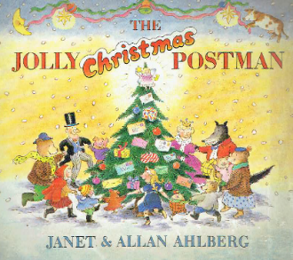 |  |  | 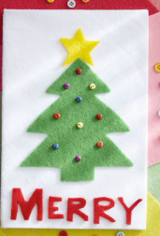
Main writing outcome: personal recount |  |  | Incidental writing opportunities: Christmas wish list, a Christmas card, instructions, get well soon card, thank you letter, wanted poster  Main writing outcome: letter to Father Christmas |  |  | Christmas cards

Spring 1
Week 1 | Week 2 | Week 3 | Week 4 |  | Week 5 | Week 6 | Week 7
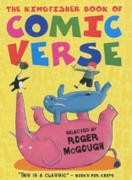  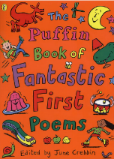  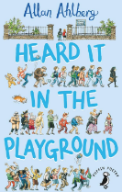  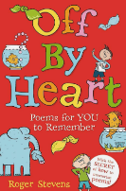 |  | 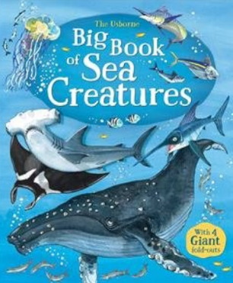  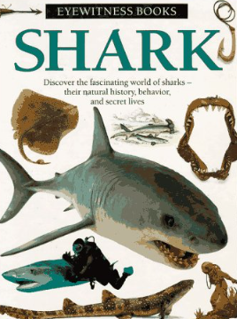  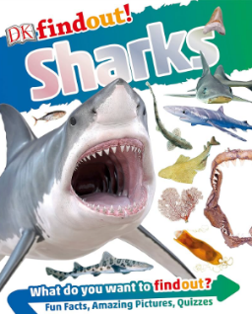  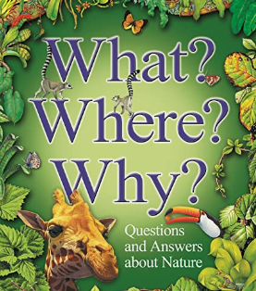
Main writing outcome: list poem |  | Incidental written opportunities: note-making, jotting questions, labels, captions  Main writing outcome: non-chronological report
Spring 2
Week 1 | Week 2 | Week 3 | Week 4 |  | Week 5
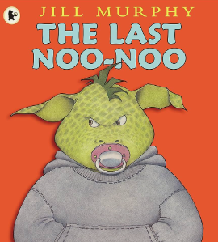 |  |  | 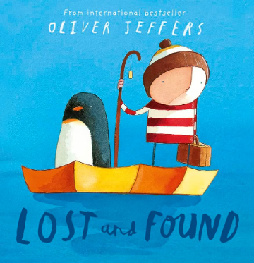
Incidental writing opportunities: questions, description  Main writing outcome: narrative |  |  |  | Main writing outcome: personal recount

Summer 1
Week 1 | Week 2 | Week 3 | Week 4 | Week 5 |  | Week 6
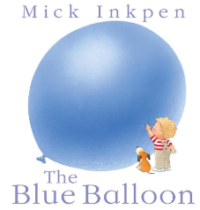  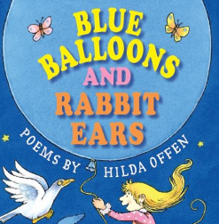 |  | 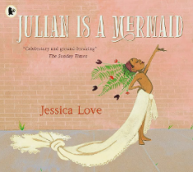 |  |  |  | 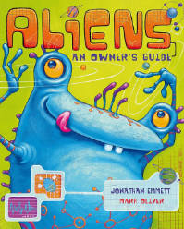  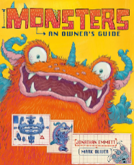
Main writing outcome: calligram (shape poem) |  | Incidental written opportunities: letter  Main writing outcome: diary entry |  |  |  | See Summer 2…
Summer 2
Week 1 | Week 2 | Week 3 | Week 4 | Week 5 |  | Week 6 | Week 7
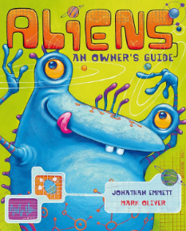  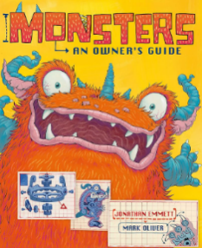 |  |  | 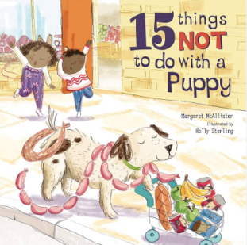
Incidental written opportunities: questions, an email, a list of fascinating facts  Main writing outcome: explanation |  |  | Writing opportunities: poster, advert, letter, instructions, poem |  | Main writing outcome: letter

